Problem Statement-
The company wanted to analyze its E-Commerce sales data across multiple countries to understand sales performance, customer behavior, order trends, and target achievement.
The objective of this project was to clean and transform the data, create a proper data model, and build an interactive Power BI dashboard that helps management track sales targets, identify top-performing sales teams and managers, analyze customer categories, and improve business decision-making.
Questions & Answers-
- At the start of the new financial year,there was a bug in the system which led to inadequate capturing of the sales channel.
- Identify the first and last timestamps when we weren't capturing this data.
Answer- I filtered the "Order Source" column for null values in Power Query to identify the records where the sales channel was not captured due to the system bug. Using the Order Datetime column, I identified the first and last timestamps of the missing records.
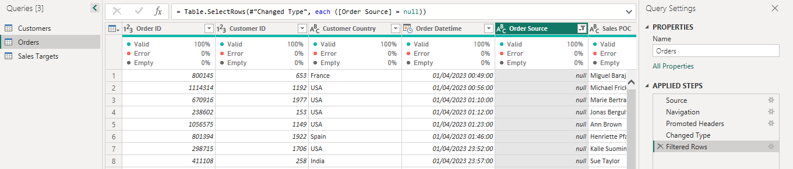
- Handle the missing values appropriately
Answer- The missing values in the Order Source column were replaced with "Website", as it was the most frequently occurring sales channel in the dataset.
- Why did you use the above approach for imputing the missing values?
Answer- I used mode imputation because:
- Order Source is a categorical column.
- "Website" was the most commonly used sales channel.
- This approach helps maintain realistic distribution of the data.
- It prevents unnecessary data loss that could occur if rows were removed.
- It ensures better accuracy for further analysis and dashboard reporting
- combine the first name and last name to create a sales manager column in power query.
Answer- To create the Sales Manager column in Power Query, I combined the First Name and Last Name columns using the Merge Columns feature and used a space “ “ as separator.

- Create a data model with the three tables.
Answer- To create the data model, I established relationships between the three tables in Model View in Power BI.
a. Orders table is related to Sales Targets by Sales POC in a 1:many bidirectional relationship (from Sales Targets to Orders)
b. Orders table is related to Customers by Sales POC in a 1:many single bidirectional relationship (from customers to Orders)
c. Bidirectional is needed here because we want the filters to work in both directions.

- We want to understand sales tragets and their completion rates.
  - Define three buckets: Target not met, Target met, Exceeded Target for Sales POCs and plot the three categories on an appropriate chart to see the counts.
Answer- I created a calculated column to calculate total sales for each Sales POC.
SalesbyPOC =SUMX(
FILTER(Orders, Orders[Sales POC] = 'Sales Targets'[Sales POC]),
Orders[Order Value])

- Create Target Buckets
I used the SWITCH function to categorize Sales POCs based on their target achievement status.
Target Bucket =SWITCH(
TRUE(),
'Sales Targets'[SalesbyPOC] < 'Sales Targets'[2023 Sales Target], "Target Not Met",
'Sales Targets'[SalesbyPOC] = 'Sales Targets'[2023 Sales Target], "Target Met",
'Sales Targets'[SalesbyPOC] > 'Sales Targets'[2023 Sales Target], "Target Exceed”)

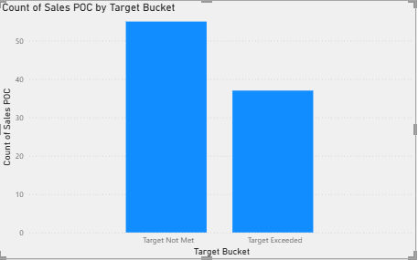

  - Which sales teams were given how much total sales targets in total.which sales manager was given the highest Target? Did he/she meet that Target?
Answer- Alpha sales team was assigned the highest targets .The Alpha team total sales target were 3690000.

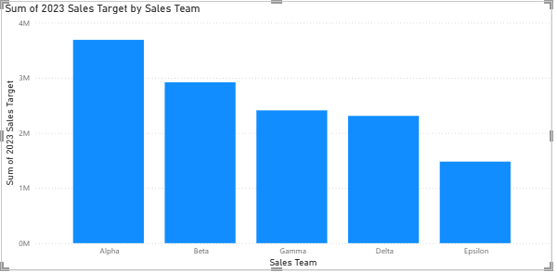

Benjamin Chen and Noah Meier were given the highest target. Benjamin Chen did not meet the sales target while Noah Meier met it.
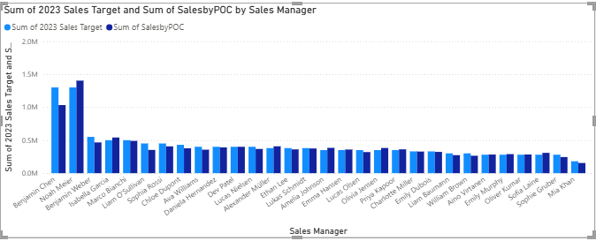

  - On average,how much short were actual sales from targets for the Sales POCs who did not complete them .

Answer-Create a new DAX column for finding the difference between the Actual Sales and the Target. If it is negative, it means that target has not been met.
we need to simply filter this column for negative values and find the average. We will do this using a slicer and a Card visual for the average.

  - Plot the % target reached per Sales Manager in each team.

Answer- Create a new Sales Manager Targets table using dax

Sales Manager Target Completion = SUMMARIZE('Sales Targets', 'Sales
Targets'[Sales Manager], "Total Sales", SUM('Sales Targets'[SalesbyPOC]),
"Total Target", SUM('Sales Targets'[2023 Sales Target]) , "% target
completion", 100*SUM('Sales Targets'[SalesbyPOC])/SUM('Sales Targets'
[2023 Sales Target]))

Add Sales Manager Target Completion Table to the Data Model so that filters work properly. A relationship with Sales Targets table can be created (1: many, bidirectional).
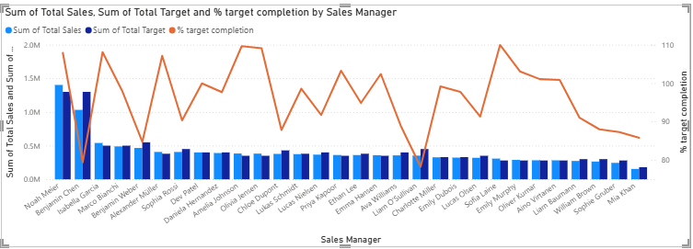

we can see that Noah Meier had the highest Sale, and was able to exceed the target by approx ~8% as the actual sales was ~108% of the target.

- In each country,display which sales Managers have been most successful
- In terms of sales value- In countries where Noah Meier generated the highest total sales value, he was considered the most successful Sales Manager in terms of sales value.

- In terms of number of orders and customers- Noah Meier was the most successful Sales Manager in terms of the number of orders and customers, as he handled a total of 298 orders and served 277 customers, which were the highest among all Sales Managers.

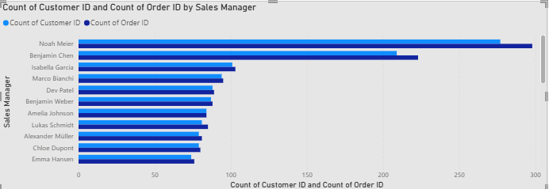

- We want to understand the order patterns to forecast demond better. Create an Orders trends (number of orders as well as value) across months. This will allow us to gauge which months were best for the company from sales standpoint.

Answer- To understand order patterns and forecast demand better, I created monthly order trend visualizations using the Orders table.

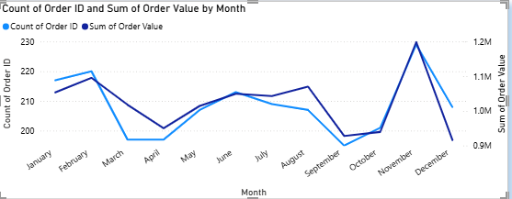

The monthly order trend analysis showed fluctuations in both the number of orders and sales value throughout the year.
- February and November recorded strong sales performance.
- November had the highest number of orders as well as the highest sales value.
- April and September showed comparatively lower sales performance.
- The trend indicated that customer demand increased significantly toward the end of the year.
- We want to understand which country fared how well in terms of number orders and avarage order value.

Answer- To understand country-wise performance, I created map visualizations using customer country data.
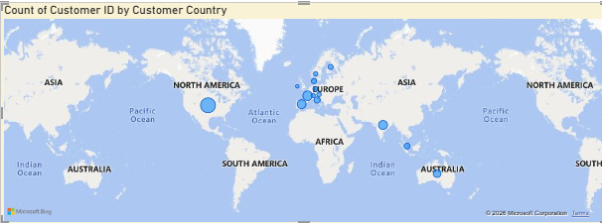

Some countries generated a higher number of orders, indicating strong customer demand.
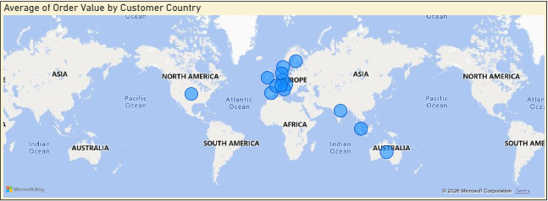
Certain countries showed higher average order values, meaning customers in those regions spent more per order.European countries showed strong overall performance across both metrics.This analysis helped identify high-performing markets and regions with strong revenue potential.

- In each category and gender of customers, what % of customers did not place an order.
Answer- To identify the percentage of customers who did not place any orders across different customer categories and genders, I performed the following analysis.
Create a Calculated Column-
I created a calculated column in the Customers table to identify customers who did not place any order.
DidNotOrder =
IF(
COUNTROWS(RELATEDTABLE(Orders)) = 0,
1,
0)

Create a Measure-
I created a measure to calculate the percentage of customers who did not place an order.
% Customers Did Not Order =
DIVIDE(
SUM(Customers[DidNotOrder]),
COUNTROWS(Customers),
0
)

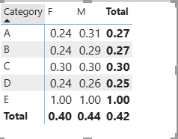

- Which order source proved to be most used by customers across various countries? Plot an appropriate chart to demonstrate the same.
Answer- the most commonly used order source across different countries, I analyzed the Order Source data from the Orders table.Used Customer Country as the category field and Order Source as the legend field.Calculated the total number of orders using Order ID.Created a Stacked Bar Chart / Stacked Column Chart to compare order sources across countries.
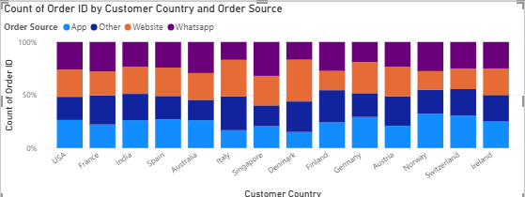
- Website was the most commonly used order source across most countries.
- App orders also contributed significantly in several countries.
- WhatsApp and Other sources had comparatively lower usage.
- Countries such as Germany, France, and the United Kingdom showed strong usage of Website orders.

- The catagory of customers stores a lot of hidden insights . Which category of customers:
- Has most indian males-
Answer- After analyzing the customer data, it was found that Category A had the highest number of Indian male customers with a total count of 44 customers, followed by Category B with 41 customers and Category C with 19 customers.
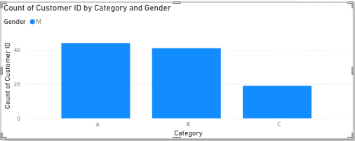

- Is the youngest on average-
Answer- After analyzing the average age across customer categories, it was found that Category E was the youngest on average, with the lowest average customer age compared to the other categories.

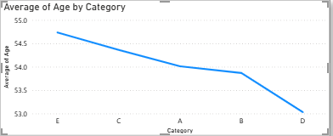

- Has the highest sales-
Answer- After analyzing the sales by customer category, it was observed that Category D generated the highest sales value. However, the sales values of Categories A, B, and D were very close to each other, indicating similar performance levels. In contrast, Category C generated comparatively lower sales than all other categories.

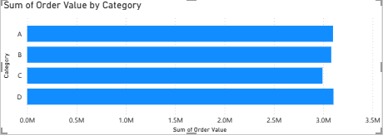

- Has the most number of sales POCs in the Delta team-
Answer- After analyzing the Delta team data, it was found that all Category number of Sales POCs 12.
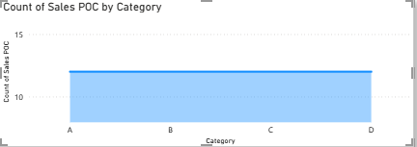

  - I created a sales ‘target page’ and created a KPI chart acutal sales and target sales. This page include Sales POC, Sales Manager and Sales team.
  - I also created a Drill Through report from a Map of total sales in each country to the Sales Manager’ individual sales in those countries,
  - I created a slideshow using a bookmark for each sales team to present the sales data to stakeholders.
  - I also created a mobile view and include top 4-5 visuals per page.

